ONEWAY SA BY HAD
/STATISTICS DESCRIPTIVES HOMOGENEITY WELCH
/PLOT MEANS
/MISSING ANALYSIS.

Oneway

Notes
Output Created |  | 05-May-2019 23:32:36
Comments
Input | Active Dataset | DataSet0
Input | Filter | <none>
Input | Weight | <none>
Input | Split File | <none>
Input | N of Rows in Working Data File | 30
Missing Value Handling | Definition of Missing | User-defined missing values are treated as missing.
Missing Value Handling | Cases Used | Statistics for each analysis are based on cases with no missing data for any variable in the analysis.
Syntax |  | ONEWAY SA BY HAD  /STATISTICS DESCRIPTIVES HOMOGENEITY WELCH  /PLOT MEANS  /MISSING ANALYSIS.
Resources | Processor Time | 00 00:00:00.172
Resources | Elapsed Time | 00 00:00:00.168

[DataSet0]

Descriptives
 | N | Mean | Std. Deviation | Std. Error
1-4 hours per day | 10 | 23.8000 | 11.32156 | 3.58019
4-8 hours per day | 6 | 22.1667 | 19.76276 | 8.06811
Less than an hour a day | 9 | 38.2222 | 19.13621 | 6.37874
More than 8 hours per day | 5 | 16.6000 | 6.69328 | 2.99333
Total | 30 | 26.6000 | 16.74062 | 3.05640

Descriptives
 | 95% Confidence Interval for Mean |  | Minimum | Maximum
 | Lower Bound | Upper Bound | Minimum | Maximum
1-4 hours per day | 15.7010 | 31.8990 | 14.00 | 50.00
4-8 hours per day | 1.4269 | 42.9064 | 6.00 | 60.00
Less than an hour a day | 23.5128 | 52.9316 | 15.00 | 67.00
More than 8 hours per day | 8.2892 | 24.9108 | 5.00 | 22.00
Total | 20.3490 | 32.8510 | 5.00 | 67.00

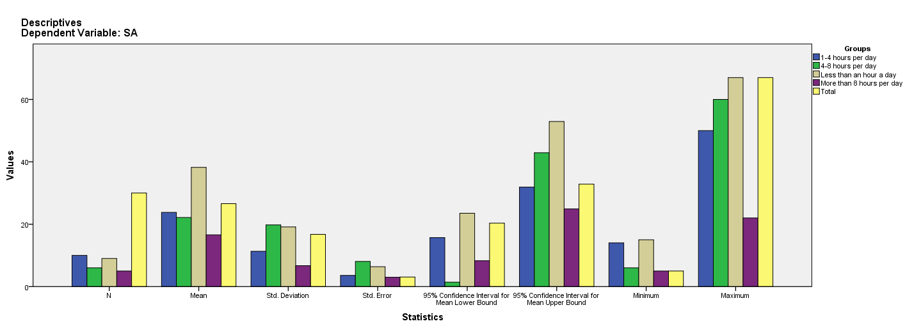

Test of Homogeneity of Variances
SA
Levene Statistic | df1 | df2 | Sig.
2.299 | 3 | 26 | .101

ANOVA
SA
 | Sum of Squares | df | Mean Square | F | Sig.
Between Groups | 1912.011 | 3 | 637.337 | 2.666 | .069
Within Groups | 6215.189 | 26 | 239.046
Total | 8127.200 | 29

Robust Tests of Equality of Means
SA
 | Statisticª | df1 | df2 | Sig.
Welch | 3.008 | 3 | 12.879 | .069
a. Asymptotically F distributed.

Means Plots

